

**as of April 2017**

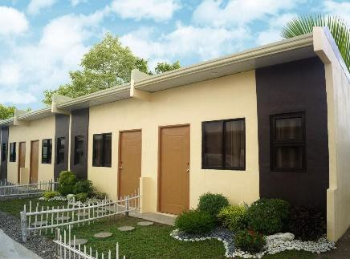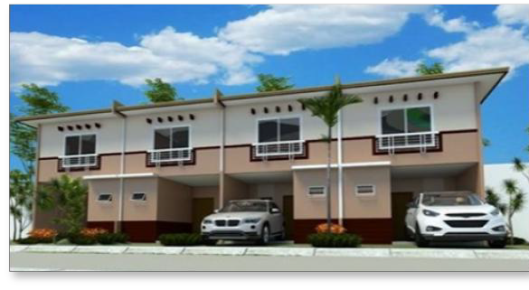

|  |  |  |  |  |
| --- | --- | --- | --- | --- |
| **HOUSE MODEL** | **ELENA INNER UNIT** | **ELENA END UNIT** | **BETTINA INNER UNIT** | **BETTINA END UNIT** |
| **Floor Area** | **22 sqm** | **22 sqm** | **44 sqm** | **44 sqm** |
| **Lot Area** | **36 sqm** | **45 sqm** | **36 sqm** | **54 sqm** |
| **TCP** | **500,000** | **602,000** | **880,000** | **1,092,000** |
| **Reservation Fee** | **3,000** | **5,000** | **5,000** | **10,000** |
| **Downpayment** | **50,000** | **90,300** | **110,000** | **136,500** |
| **Monthly Downpayment** | **3,357** | **4,739** | **7,500** | **9,036** |
| **DP terms** | **14 months** | **18 months** | **14 months** | **14 months** |
| **Loanable Amount** | **450,000** | **511,700** | **770,000** | **955,500** |
| **FINANCING** | **PAG-IBIG** | **PAG-IBIG** | **BANK** | **BANK** |
| **Interest Rate** | **4.50%** | **6.50%** | **7%** | **7%** |
| **Monthly Amortization** | | | | |
| **30 years** | **2,280** | **3,234** | **-** | **-** |
| **25 years** | **2,501** | **3,455** | **-** | **-** |
| **20 years** | **2,847** | **3,815** | **5,970** | **7,408** |
| **15 years** | **3,442** | **4,457** | **6,921** | **8,588** |
| **10 years** | **4,664** | **5,810** | **8,940** | **11,094** |
| **5 years** | **8,389** | **10,012** | **15,247** | **18,920** |

**Note :**

**1. Reservation Fee is non-refundable and non-transferable.**

**2. Prices, including reservation fees, stated above is subject to change without prior notice.**

**3. All payments should be made directly to BRIA HOMES INC.**

**4. House Turnover is BARE.**

**5. Monthly Amort is subject to change based on the prevailing rate of Pag-IBIG or Bank upon Loan Application.**

**6. Monthly Amort does not include other possible charges to be imposed by PIF, like insurances, etc.**

**For inquiries :**

**TIPIDBAHAY REALTY**

**0905237015 / MARIANNE OLANO**

A proud development of: